What we do

We focus on building community around our school, improving the place for our kids, and providing services for families.

Here are some of the things our volunteers do for the school community:

* School Canteen with a focus on healthy food choices (open Wednesday-Friday)
* Uniform shop at the school <add opening hours if you want>
* Second-hand uniform pool
* Breakfast Club, providing a free, nutritious breakfast to students
* Regular school discos
* Fun events like trivia nights
* The annual school Fair
* Scholastic Book Club
* School Banking
* Fundraising to improve the school

<amend list to reflect your activities >

We’d love to hear your ideas for improving what we do.

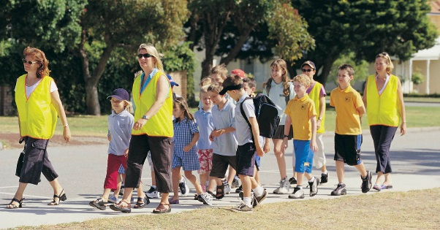

Join in!

We rely on many hands to do what we do

All offers of help make a difference, and we welcome new faces!

Some ways to help include:

* Bake for fundraising events
* Come to P&C meetings or join a sub-committee
* Run a stall at the Fair
* Turn sausages at community BBQs
* Sort lost property or the second-hand clothing pool
* Seek donations from local businesses
* Help for a few hours in the canteen
* Serve at the uniform shop for an hour a week
* Assist at school sporting events
* Get quotes for building projects

<amend list to reflect your needs/opportunities>

To find a job that suits you, come to our next meeting or join our email distribution list.

Why join in?

P&C volunteers tell us they:

* meet others in the community and make friends
* feel satisfied helping the school and making it better for the kids
* understand more about what happens at school
* love seeing the kids’ happy faces
* get to know the teachers better
* learn new skills and share my own
* set a good example for their kids

**Your children will benefit too.** Research shows that when parents are involved, students get better grades, have a better attitude to school and improved behaviour!

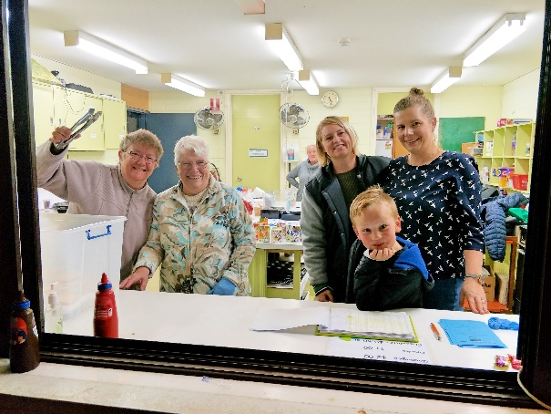

The P&C is a volunteer-run organisation that is here to support the school and community.

All school parents and carers are members – welcome!

We're the focal point for parent participation in the school. If you want to find out more or get involved, come along to our meetings or join our <email list/Facebook page>.

At the P&C, you’ll find out more about the school and have the chance to have your say.

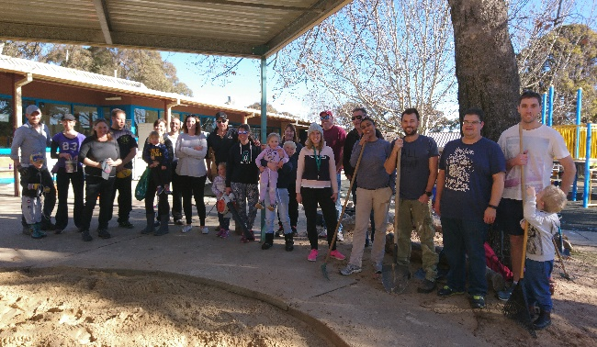

Contact us

Link up with us on Facebook <link/name> or our Website [<web](http://www.giralangps.act.edu.au/p_and_c_services) address>

Come along to our next meeting – coffee and cakes provided!

Find the date in the school newsletter/website/facebook/school sign

Chat to the P&C Volunteer Co-ordinator (or Secretary, or President) <name> <phone or email>

Or never miss a thing by joining our email distribution list (we send out information on our meetings and activities and the occasional call for help) – simply send a request to the P&C email <address>.

<choose the best ways for people to make contact with your P&C>

<insert school or P&C logo>

**Welcome to the <school name> P&C!**

<Insert a picture of parents helping or one of your services here.>

